Setting up Chrome to auto launch into kiosk mode on computer boot

Use W + R to open the Run window

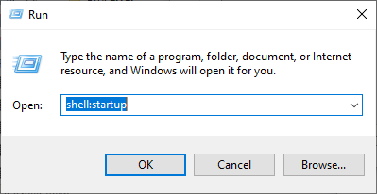

In the Open box type shell:startup and click OK to get to the Startup folder

In the Startup folder, either copy a shortcut for Chrome or create a new shortcut for it

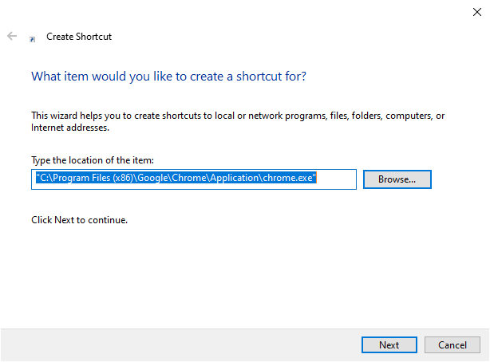

Open the Properties window for the new shortcut by right clicking on it.

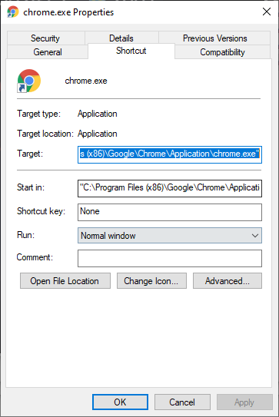

At the end of the text in the Target box, add (note the double dashes)

* --kiosk
  + To have Chrome start in a fullscreen mode that limits functionality
* --incognito
  + This helps prevent messages popping up asking to restore previous sessions
* https://████████/whateveryouwanttheTVtodisplay.com
  + This will be the website the TV will be displaying

Altogether it should look something like this:

"C:\Program Files\Google\Chrome\Application\chrome.exe" --kiosk --incognito https://██████████. ██████████████████.com/█████/████

Note: If you want to test the shortcut, make sure to close all instances of Chrome before double clicking the shortcut, otherwise Chrome will not open in kiosk mode. Likewise, any instances of kiosk mode must be closed before trying to open Chrome normally again.

Finally, restart the computer and give Chrome about a minute to open up after Windows starts again.